Self-Healing

This paper will explain the current state of the software and hardware relating to the Self-Healing project. It will briefly go over current progress, as well as plans for future work on the project.

Currently, multiple approaches are being taken in order to find the best combination of software and hardware. The software and hardware must be able to handle the requirements of very high speed sampling with a certain amount of accuracy, as well as being capable of playback with the same speed and accuracy.

One approach is using the FPGA system that we are currently using for the Fast-Steering Deformable Mirror project (Figure 1). The hardware is theoretically capable of achieving the speeds that are needed for the self-healing project. This system also allows us a high level of determinism when it comes to the actual program execution. Preliminary test are showing that this may be suitable for the project. The tests include reading a frequency on two channels, storing the data points, then playing back the frequency. Although we have not immediately seen this to be reliable for higher speeds, we feel that it is very possible and that further research will result in a solution to attain the higher speeds. The one drawback to this system is that it is not as flexible as our other option that we are currently looking into.

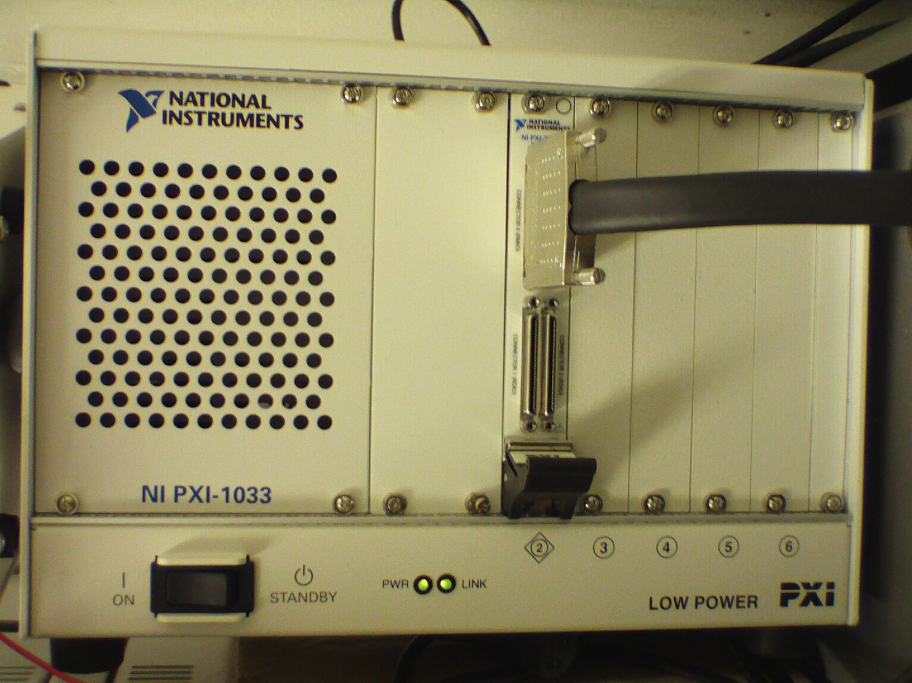
Figure 1. FPGA System (Chassis with FPGA card installed)
The second approach we are taking is to implement a different National Instruments DAQ card. This card will be run in the real-time system that we have tried previously for the Fast-Steering Deformable Mirror project. Although the real-time system was found to not be suitable for the Mirror project, we feel that it will work acceptably for the Self-Healing project since we are allowed to buffer the input instead of taking and processing the data point by point. The real-time system will have a dual-core processor. This will allow for us to retrieve data from the DAQ card’s buffer with one core while processing the data with the other core. The same is true for outputting the data. We are able to write data to the DAQ card’s buffer with one core while performing any other operations with the other core. We are currently testing an older DAQ card that we have on hand in order to prove the principle that it will work with a newer card. The benefit of using this method over the other is that it provides an immense amount of flexibility when it comes to programming and testing the card.

For future work, we plan to continue testing both methods until we determine which one is more suited for solving the problem. If neither method results in a usable solution, we may revert back to testing a previous card from a different vendor that was somewhat less desirable in the programming aspects but may be able to produce good results. Other possibilities are also available, such as using two oscilloscopes and four AWGs to produce the signals, store the signals, then play back the signals.

